 | SAKR MANNING AGENCY  FOR RECRUITING EGYPTIAN LABOR ABROAD | Issue Date | 15.05.2022
 |  | Revision Date | 27.05.2023
 | Crewing Management Manual  Seafarer Employment Application | Revision | 1.2
 |  | Page | 3
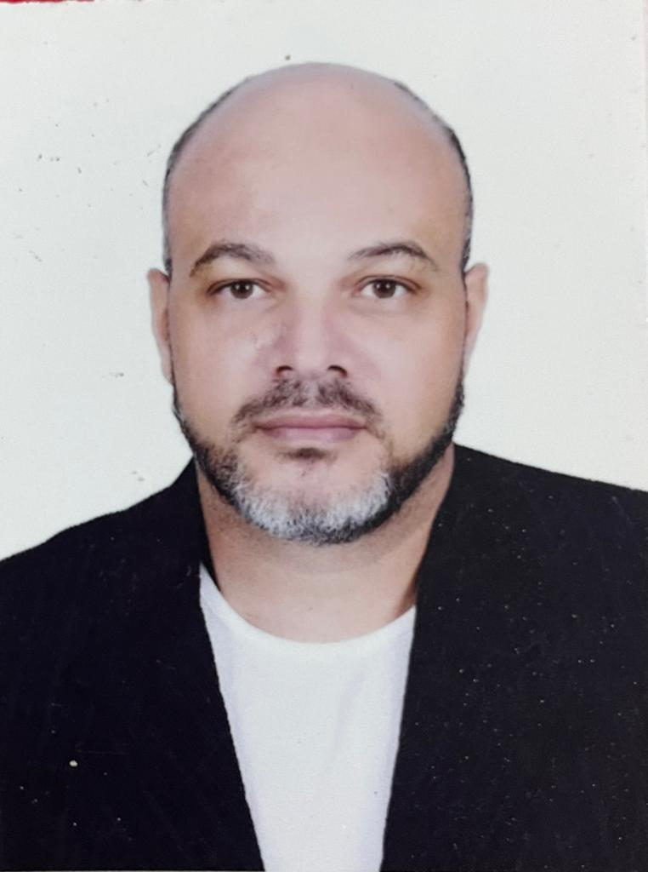
Application For Position as | Chief Electrician
Register Code. | ER-1.012
Other Position (If Any)
Register Date | 31/01/2024
Last up Date Data | 20-1-2024
Expected Salary | 3000 $

1. PERSONAL DETAILS
Full Name |  | Hossam El-din Mohamed Hassan
Date Of Birth |  | 27/10/1972 |  |  |  |  |  | Place Of Birth |  |  |  |  |  |  | Cairo
Nationality |  | Egyptian |  |  |  |  |  | Marital Status |  |  |  |  |  |  | Single |  |  |  |  |  |  | Married
Height (Cm) |  | 178 Cm |  |  |  |  |  | Overall Size |  |  |  |  |  |  | 2 XXL |  |  |  |  | Shirt Size |  |  |  |  | 2 xxL
Weight (Kg) |  | 95 Kg |  |  |  |  |  | Trouser Size |  |  |  |  |  |  | 36 Jeans |  |  |  |  | Shoes Size |  |  |  |  | 43
2. EDUCATION
College / School |  | A Diploma of Industrial electricity 1990
Marline Test |  | Issued Date |  |  |  | Result % |  |  |  | Issued By (Authority) |  |  |  |  |  |  |  |  | Issued At
English Language |  | Fluent |  |  |  |  | Good |  |  |  |  | Average |  |  |  |  |  |  | Poor
……… Language  ( ) |  | Fluent |  |  |  |  | Good |  |  |  |  | Average |  |  |  |  |  |  | Poor
3. CONTACT DETAILS
Home Address / City |  | Suez - el Malaha ,16 elsafa st,
E-Mail |  | Hoss.hoss32@yahoo.com |  |  |  |  |  |  | Mobile / Tel |  |  |  |  | 01000263334

4. TRAVEL DOCUMENTS
Type |  | Document No. |  |  | ISS. Date |  |  | Exp. Date |  |  |  |  | ISS. By (Authority) |  |  |  |  |  |  |  |  | Place of Issue
Passport |  | A26266625 |  |  | 11-1-2020 |  |  | 10-1-2027 |  |  |  |  | Egyptian Authority |  |  |  |  |  |  |  |  | Suez
Seaman Book |  | 500007150 |  |  | 02-3-2020 |  |  | 24-2-2025 |  |  |  |  | EAMS |  |  |  |  |  |  |  |  | Alex.
Other Seaman Book

5. PROFESSIONAL QUALIFICATION / CERTIFICATE OF COMPETENCY
Certificate Name |  |  |  | Number | Issue Date |  |  |  |  |  | Expiry Date |  |  |  |  | Issued By |  |  |  |  |  |  |  | Issued At
COC ( Rank)  ………….. |  |  |  | 1818/20/EG | 06/2/2020 |  |  |  |  |  | 15/1/2025 |  |  |  |  | EAMS |  |  |  |  |  |  |  | Alex.
GOC |  |  |  |  |  |  |  |  |  |  |  |  |  |  |  | NTRA |  |  |  |  |  |  |  | Cairo
D.P. INDUCTION
D.P. ADVANCED
D.P. OPERATOR (UNLIMITED)
6. NEXT OF KIN
Full Name | Hoda Mostafa Gaber Mohamed |  |  |  |  |  |  |  |  |  |  |  |  | Relationship |  |  |  | Wife
Address | Suez- 16 el Safa streer, El-malaha
Tel. No. | 01019816072 |  |  |  |  |  |  |  | Mobile
7. HEALTH CERTIFICATES & VACCINATIONS
Flag State |  |  | Number |  |  | Issue Date |  |  |  |  | Expiry Date |  |  |  |  |  | Issued By |  |  |  |  |  | Issued At
International Medical |  |  |  |  |  |  |  |  |  |  |  |  |  |  |  |  | EAMS |  |  |  |  |  | Alex.
Yellow Fever |  |  |  |  |  |  |  |  |  |  |  |  |  |  |  |  | Ministry of Health
Cholera |  |  |  |  |  |  |  |  |  |  |  |  |  |  |  |  | Ministry of Health
Covid-19 |  |  | Vaccination Name |  |  | First Dose |  |  |  |  | Second Dose |  |  |  |  |  | (Other Does or Remarks)
 |  |  | Astrazeneca short interval |  |  | 27-03-2022 |  |  |  |  | 26-04-2022

8. MARINE COURSES
Course Name | Number | Issue Date | Expiry Date | Issued By / At
Personal Survival Techniques | A-VI/1-1 | 11-1-2020 | 16-1-2020 | Alex
Proficiency In Personal Survival Techniques
Fire Prevention and Fire Fighting | A-VI/1-2 | 11-1-2020 | 16-1-2020 | Alex
Advanced Fire Prevention and Fire Fighting
Elementary First Aid | A-VI/1-3 | 11-1-2020 | 16-1-2020 | Alex
Medical Care Studies
Personal Safety and Social Responsibilities | A-VI/1-4 | 11-1-2020 | 16-1-2020 | Alex
Proficiency Of Security Awareness Training Seafarers
Proficiency as a ship Security officer ( PSSO )
Proficiency In Survival Craft & Rescue Boats
G.M.D.S.S
Communications
Advanced Communications
ECDIS Advanced Simulator (Management Level)
ECDIS Simulator (Operation Level)
Prevention and Combating of Marine Pollution
Radar & ARPA Simulator and Search &rescue
ARPA Simulator and Search
Marine Radar and automatic Radar Plotting
Bridge resource Management (B.R.M)
Engine resource Management (E.R.M)
Navigational Watch keeping
Proficiency for Rating forming part of Navigational watch (II/4) |  |  |  | EAMS / Alex.
High voltage training – operation of ship (1000 Volt and More)
Passenger Safety Cargo Safety and Hull integrity
Crowd Management Training
Crisis Management and Human Behavior Training
Safety training for Personal Prov. Direct Passengers
Practical Ability to Prepare Meals and (MLC 2006)
Personal Hygiene and Envir. Protection (MLC 2006)
Safety and Health in the Provision Meals (MLC 2006)
Food Storage and inventory Control (MLC 2006)
Ships Cook Certificate (MLC 2006) |  |  |  | EAMS / Alex.
Abel Seafarer Deck
Proficiency for Abel Seafarer Deck ( II/5 ) |  |  |  | EAMS / Alex.
Engineering Watch keeping |  |  |  | EAMS / Alex.
Proficiency for Rating forming part of a watch in engine room
Abel Seafarer Engine
Proficiency for Abel Seafarer Engine ( III/5 ) |  |  |  | EAMS / Alex.
Electro Technical Rating
Proficiency for Electro Technical rating ( III/7 ) |  |  |  | EAMS / Alex.

 |  |  | COMPLETE SEA – SERVICE DETAILS
Name: |  |  |  |  |  |  |  |  |  |  |  |  |  | Rank:- |  |  |  |  | Register Code:
Company Name |  |  |  |  |  | Rank | Vessel Name |  |  | Flag |  |  | Signed On |  |  | Signed Off |  |  | Period | Vessel Type |  |  | D.W.T. |  | Engine Type |  | BH |  |  |  | KW
ALSALAM |  |  |  |  |  | Electrician | ALSALAM ALSudy |  |  | Panama |  |  | 5-1994 |  |  | 1-1999 |  |  | 38 Months | RORO Passenger
ALSALAM |  |  |  |  |  | Electrician | ALSALAM PASCOLI |  |  | Panama |  |  | 4 -1999 |  |  | 09-2002 |  |  | 36 Months | RORO  Passenger
ALSALAM |  |  |  |  |  | Chief Electrician | AlSALAM  Carducci 92 |  |  | Panama |  |  | 09-2002 |  |  | 12-2003 |  |  | 13 Months | RORO  Passenger
AL SALAM |  |  |  |  |  | Ch. Electrician | ALSALAM CARDUCCI |  |  | Panama |  |  | 12-2003 |  |  | 04-2006 |  |  | 26 Months | RORO  Passenger
ALSALAM |  |  |  |  |  | Chief  Electrician | ALSALAM GUDO |  |  | Italy |  |  | 02-2007 |  |  | 05-2007 |  |  | 3 months | RORO
ADRIATICA |  |  |  |  |  | Chief.  Electrician | ADRIATICA |  |  | Italy |  |  | 07-2007 |  |  | 09-2009 |  |  | 28 Months | RORO  Passenger
AlYousefia |  |  |  |  |  | Chief  electrician | AlYousefia |  |  | Panama |  |  | 10-2009 |  |  | 09 -2012 |  |  | 32 Months | RORO  Passenger
Salem AlMaccrani |  |  |  |  |  | Chief  Electrician | Trans Landia |  |  | Panama |  |  | 07-2013 |  |  | 02-2014 |  |  | 7 Months | RORO  Passenger
UNI-K |  |  |  |  |  | Chief  Electrician | UNI-K |  |  | TOGO |  |  | 05-2014 |  |  | 10-2014 |  |  | 6 Months | Cargo
Force Shipping Line |  |  |  |  |  | Chief  Electrician | Force One |  |  | Panama |  |  | 02-2015 |  |  | 05-2015 |  |  | 4 Months | Cargo
SALEM ALMACCRUNI |  |  |  |  |  | Chief  Electrician | Ruzgar |  |  | Panama |  |  | 08-2015 |  |  | 12-2016 |  |  | 16 Months | RORO  Passenger
SALEM ALMACCRUNI |  |  |  |  |  | Chief  Electrician | Ruzgar |  |  | Panama |  |  | 02-2017 |  |  | 06-2018 |  |  | 16 Months | RORO  Passenger
SALEM ALMACCRUNI |  |  |  |  |  | Chief  Electrician | ALSalmy 1 |  |  | UAE |  |  | 07-2018 |  |  | 01-2020 |  |  | 18 Momths | RORO  Passenger
SALEM ALMACCRUNI |  |  |  |  |  | Chief  Electrician | ALSalmy 7 |  |  | Marshal Island |  |  | 08-2020 |  |  | 06-2022 |  |  | 22 Months | Heavy Lift
SALEM ALMACCRUNI |  |  |  |  |  | Chief  Electrician | Whiteland |  |  | St Kitts& nevis |  |  | 08-2022 |  |  | 01-2024 |  |  | 16 Months | RORO
 |  | SPECIALISED EXPERIENCE
 |  | Name |  |  |  |  |  |  |  |  |  |  |  | Type |  |  |  | From |  |  | To |  |  | Comments
 |  | I declare that the information I have given is, to the best of my knowledge, true and complete. I also declare that the documents submitted are genuine, given and sign by persons whose names appear on them.
 |  |  |  |  |  |  |  |  |  |  |  |  |  |  |  |  | 21-01-2024 |  |  |  |  |  |  | Hossam Hassan
 |  |  |  |  |  |  |  |  |  |  |  |  |  |  |  |  |  |  | DATE |  |  |  |  |  | SIGNATURE

